Screenshot 1 – Task creation – general tab. 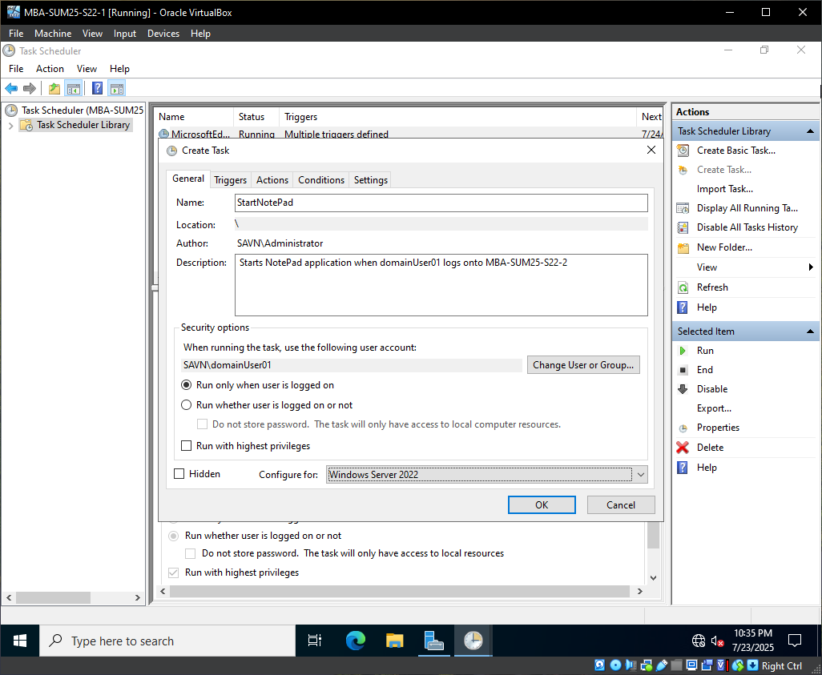
Screenshot 2 – Task creation – trigger.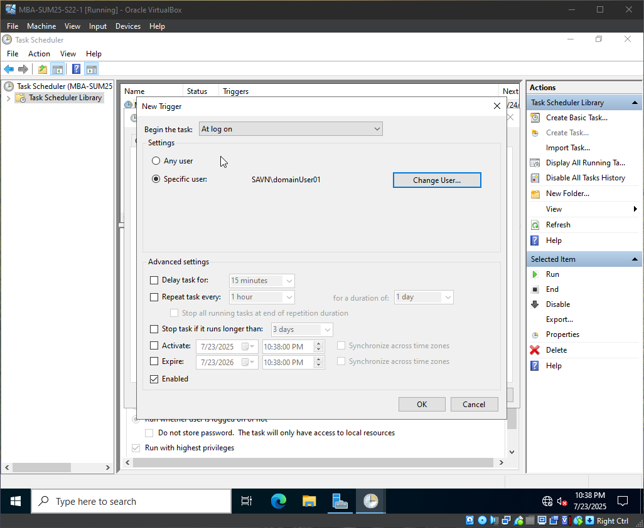
Screenshot 3 – Task creation – action.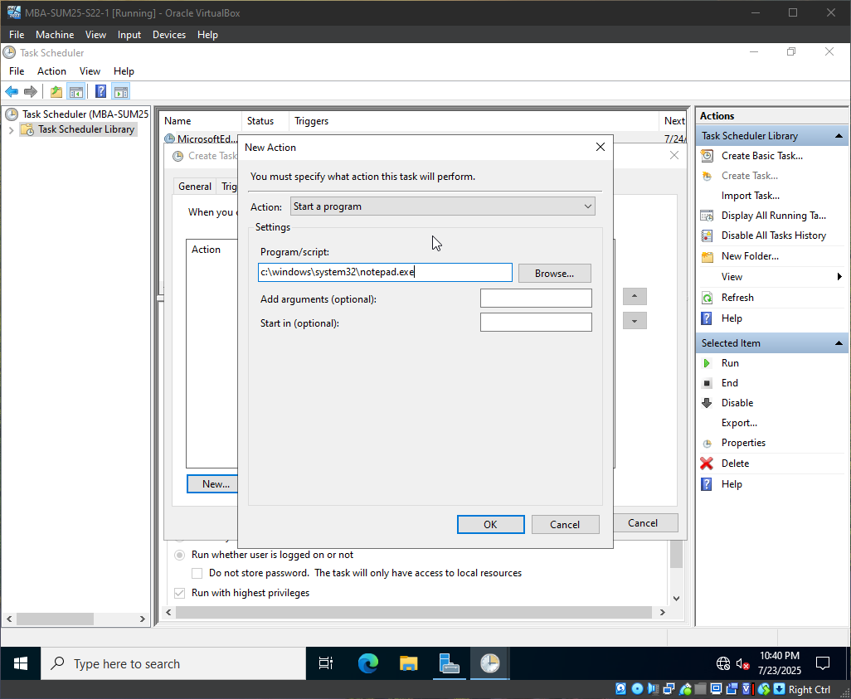
Screenshot 4 – Task executing for domainUser01 on MBA-SUM25-S22-2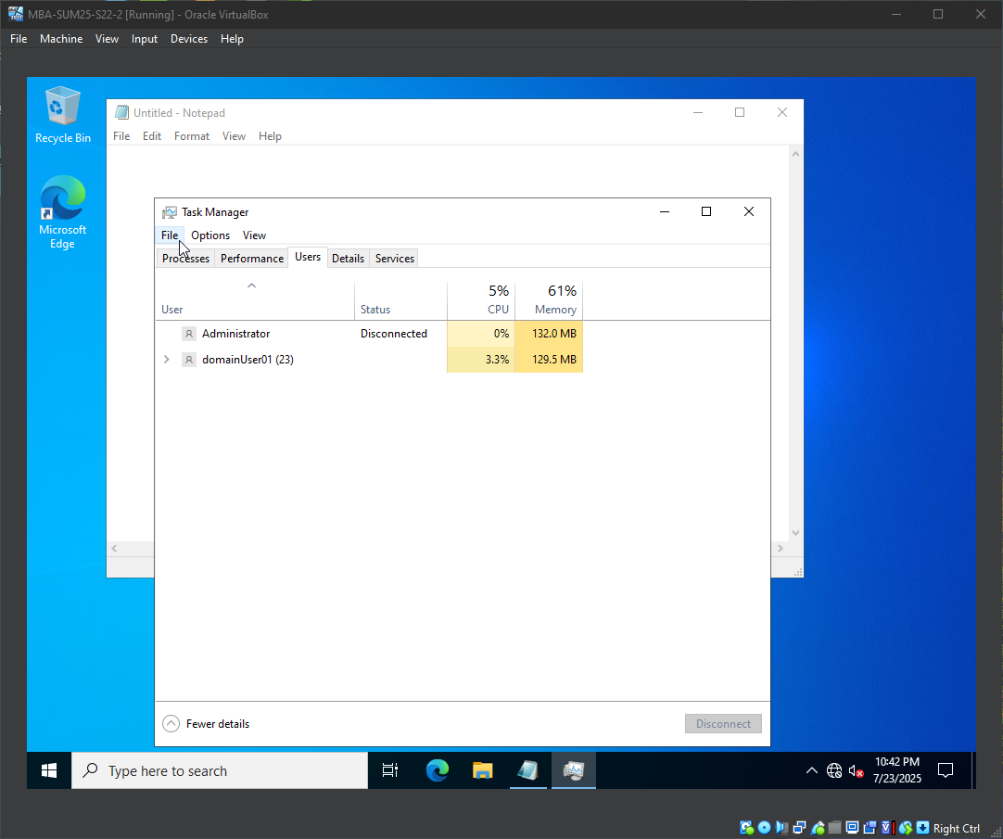
Screenshot 5 – Task listed on remote system MBA-SUM25-S22-2 running under domainUser01.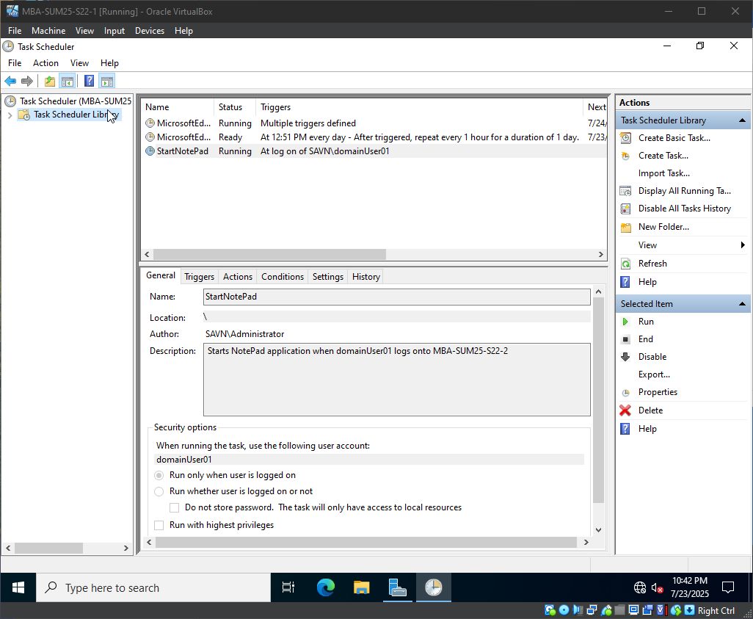
Screenshot 6 – displayDateMessage task creation – general tab.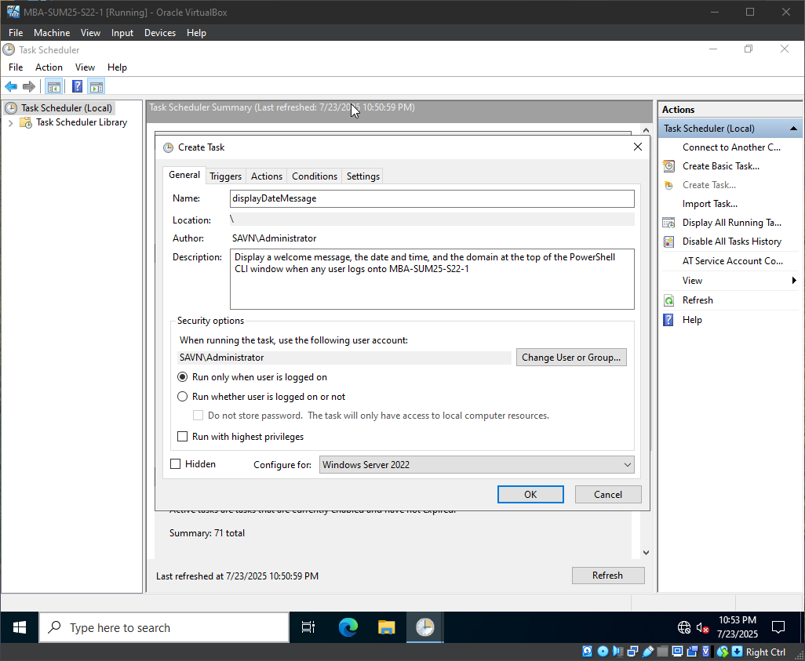
Screenshot 7 – displayDateMessage task creation – triggers tab.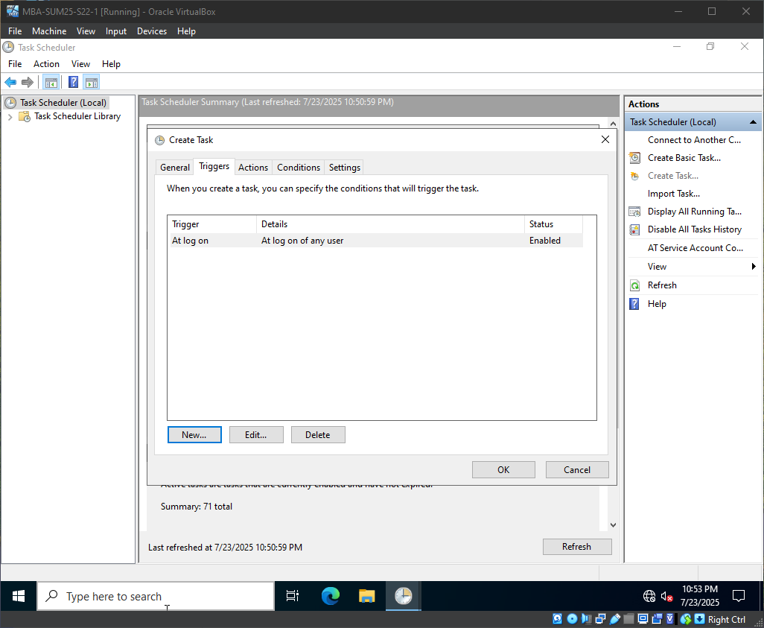
Screenshot 8 – displayDateMessage task creation – action tab.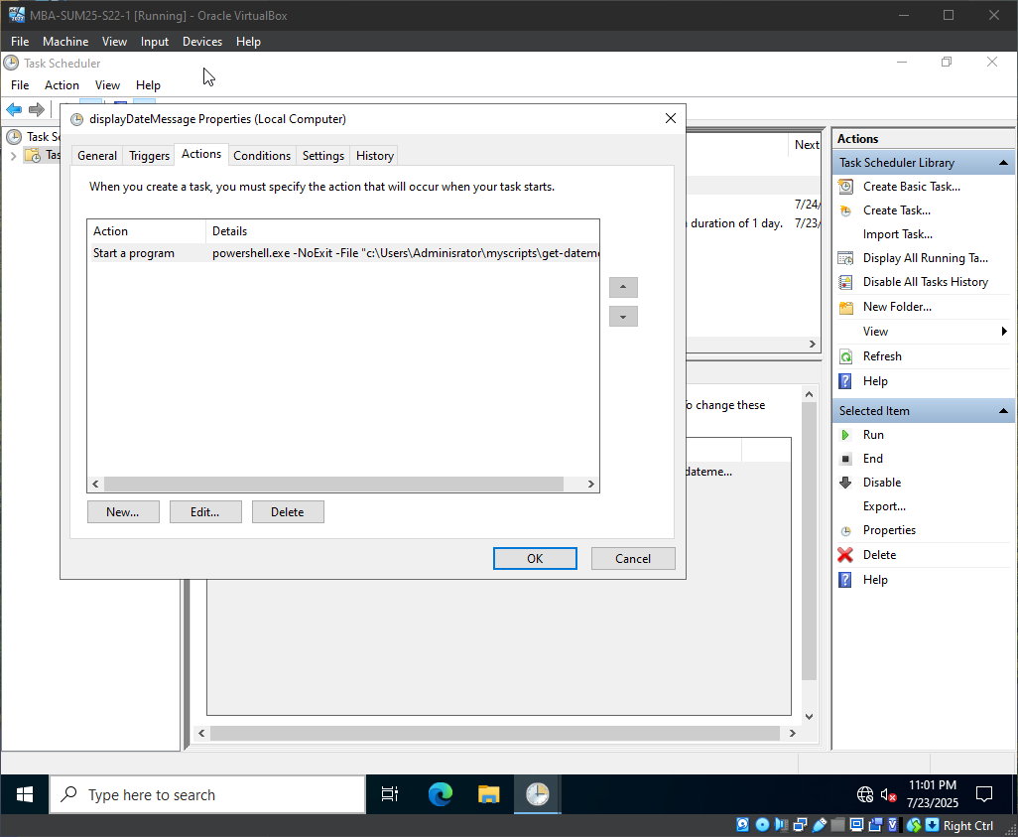
Screenshot 9 – displayDateMessage task listed as registered in the task library. 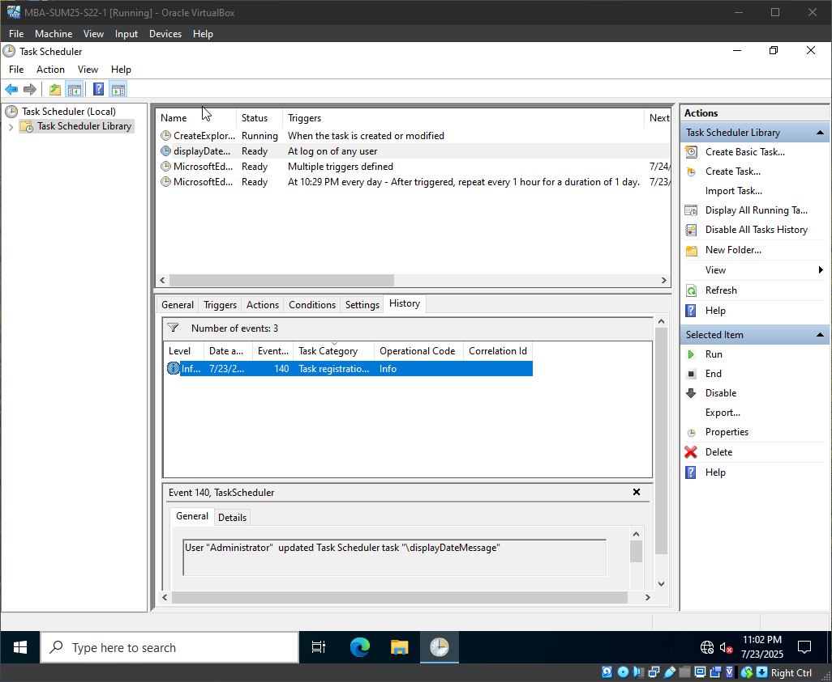
Screenshot 10 – displayDateMessage task executing.